# Exercises: Table Relations

This document defines the **exercise assignments** for the [MySQL course @ Software University.](https://softuni.bg/opencourses/databases-basics-mysql)

## One-To-One Relationship

Create two tables as follows. Use appropriate data types.

|  |  |  |  |
| --- | --- | --- | --- |
| **people** | | | |
| **person_id** | **first_name** | **salary** | **passport_id** |
| 1 | Roberto | 43300.00 | 102 |
| 2 | Tom | 56100.00 | 103 |
| 3 | Yana | 60200.00 | 101 |

|  |  |
| --- | --- |
| **passports** | |
| **passport_id** | **passport_number** |
| 101 | N34FG21B |
| 102 | K65LO4R7 |
| 103 | ZE657QP2 |

**Insert the data from the example above.**

* Alter table **people** and make person_ida primary key.
* Create a foreign key between **people** and **passports** by using the passport_id column.
* Think about which passport field should be UNIQUE.
* Format salary to **second** digit after decimal point.

Submit your queries by using "**MySQL run queries & check DB**" strategy**.**

**CREATE TABLE `people` (**

**`person_id` INT NOT NULL,**

**`first_name` VARCHAR(20),**

**`salary` DECIMAL(7 , 2 ),**

**`passport_id` INT UNIQUE**

**);**

**CREATE TABLE `passports` (**

**`passport_id` INT NOT NULL UNIQUE,**

**`passport_number` VARCHAR(20)**

**);**

**ALTER TABLE `people`**

**ADD PRIMARY KEY (`person_id`);**

**ALTER TABLE `people`**

**ADD CONSTRAINT `fk_people_passports`**

**FOREIGN KEY (`passport_id`) REFERENCES passports(passport_id);**

**INSERT INTO `passports`**

**(`passport_id`, `passport_number`)**

**VALUES**

**('101', 'N34FG21B'),**

**('102', 'K65LO4R7'),**

**('103', 'ZE657QP2');**

**INSERT INTO `people`**

**(`person_id`, `first_name`, `salary`, `passport_id`)**

**VALUES**

**('1', 'Roberto', ROUND('43300', 2), '102'),**

**('2', 'Tom', ROUND('56100', 2), '103'),**

**('3', 'Yana', ROUND('60200', 2), '101');**

## One-To-Many Relationship

Create two tables as follows. Use appropriate data types.

|  |  |  |
| --- | --- | --- |
| **manufacturers** | | |
| **manufacturer_id** | **name** | **established_on** |
| 1 | BMW | 01/03/1916 |
| 2 | Tesla | 01/01/2003 |
| 3 | Lada | 01/05/1966 |

|  |  |  |
| --- | --- | --- |
| **models** | | |
| **model_id** | **name** | **manufacturer_id** |
| 101 | X1 | 1 |
| 102 | i6 | 1 |
| 103 | Model S | 2 |
| 104 | Model X | 2 |
| 105 | Model 3 | 2 |
| 106 | Nova | 3 |

**Insert the data from the example above.**

* Add primary and foreign keys.

Submit your queries by using "**MySQL run queries & check DB"** strategy.

**CREATE TABLE `manufacturers` (**

**`manufacturer_id` INT PRIMARY KEY AUTO_INCREMENT,**

**`name` VARCHAR(20),**

**`established_on` date**

**);**

**CREATE TABLE `models` (**

**`model_id` INT PRIMARY KEY AUTO_INCREMENT,**

**`name` VARCHAR(20),**

**`manufacturer_id` INT NOT NULL,**

**CONSTRAINT `fk_models_manufacturers`**

**FOREIGN KEY (`manufacturer_id`) REFERENCES `manufacturers`(`manufacturer_id`)**

**);**

**INSERT INTO `manufacturers`**

**(`manufacturer_id`, `name`, `established_on`)**

**VALUES**

**(1, 'BMW', '1916-03-01'),**

**(2, 'Tesla', '2003-01-01'),**

**(3, 'Lada', '1966-05-01');**

**INSERT INTO `models`**

**(`model_id`, `name`, `manufacturer_id`)**

**VALUES**

**('101', 'X1', 1),**

**('102', 'i6', 1),**

**('103', 'Model S', 2),**

**('104', 'Model X', 2),**

**('105', 'Model 3', 2),**

**('106', 'Nova', 3);**

## Many-To-Many Relationship

Create three tables as follows. Use appropriate data types.

|  |  |
| --- | --- |
| **exams** | |
| **exam_id** | **name** |
| 101 | Spring MVC |
| 102 | Neo4j |
| 103 | Oracle 11g |

|  |  |
| --- | --- |
| **students** | |
| **student_id** | **name** |
| 1 | Mila |
| 2 | Toni |
| 3 | Ron |

|  |  |
| --- | --- |
| **students_exams** | |
| **student_id** | **exam_id** |
| 1 | 101 |
| 1 | 102 |
| 2 | 101 |
| 3 | 103 |
| 2 | 102 |
| 2 | 103 |

**Insert the data from the example above.**

* Add primary and foreign keys.
* Have in mind that the table student_exams should have a

**composite** primary key.

Submit your queries by using "**MySQL run queries & check DB**" strategy**.**

**CREATE TABLE `students` (**

**`student_id` INT PRIMARY KEY,**

**`name` VARCHAR(50)**

**);**

**CREATE TABLE `exams` (**

**`exam_id` INT PRIMARY KEY,**

**`name` VARCHAR(225)**

**);**

**CREATE TABLE `students_exams` (**

**`student_id` INT,**

**`exam_id` INT,**

**CONSTRAINT PK_StudentID_ExamID PRIMARY KEY (student_id , exam_id),**

**CONSTRAINT FK_StudentsExams_Students FOREIGN KEY (student_id)**

**REFERENCES `students` (student_id),**

**CONSTRAINT FK_StudentsExams_ExamID FOREIGN KEY (exam_id)**

**REFERENCES `exams` (exam_id)**

**);**

**INSERT INTO `students`**

**(`student_id`, `name`)**

**VALUES**

**(1, 'Mila'),**

**(2, 'Toni'),**

**(3, 'Ron');**

**INSERT INTO `exams`**

**(`exam_id`, `name`)**

**VALUES**

**('101', 'Spring MVC'),**

**('102', 'Neo4j'),**

**('103', 'Oracle 11g');**

**INSERT INTO `students_exams`(`student_id`,`exam_id`) VALUES**

**(1, 101),**

**(1, 102),**

**(2, 101),**

**(3, 103),**

**(2, 102),**

**(2, 103);**

## Self-Referencing

Create a single table as follows. Use appropriate data types.

|  |  |  |
| --- | --- | --- |
| **teachers** | | |
| **teacher_id** | **name** | **manager_id** |
| 101 | John |  |
| 102 | Maya | 106 |
| 103 | Silvia | 106 |
| 104 | Ted | 105 |
| 105 | Mark | 101 |
| 106 | Greta | 101 |

**Insert the data from the example above.**

* Add primary and foreign keys.
* The foreign key should be between manager_id and teacher_id.

Submit your queries by using " **MySQL run queries & check DB**" strategy**.**

**CREATE TABLE `teachers` (**

**`teacher_id` INT PRIMARY KEY,**

**`name` VARCHAR(50),**

**`manager_id` INT);**

**INSERT INTO `teachers`**

**VALUES**

**(101,'John', NULL),**

**(102,'Maya', 106),**

**(103,'Silvia', 106),**

**(104,'Ted', 105),**

**(105,'Mark', 101),**

**(106,'Greta', 101);**

**ALTER TABLE `teachers`**

**add constraint fk_teacher foreign key (manager_id) references `teachers`(`teacher_id`);**

## Online Store Database

Create a new database and design the following structure:

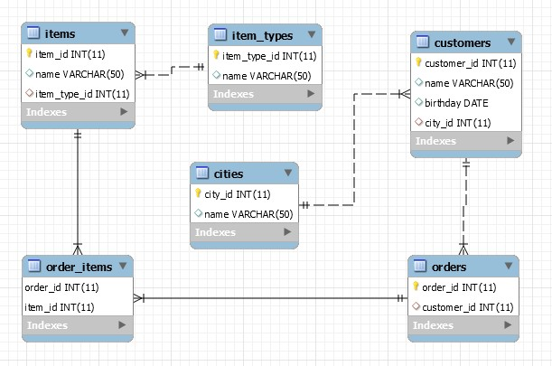

Submit your queries by using "**MySQL run queries & check DB"** strategy**.**

**CREATE TABLE `items` (**

**`item_id` INT(11) PRIMARY KEY,**

**`name` VARCHAR(50),**

**`item_type_id` INT(11)**

**);**

**CREATE TABLE `item_types` (**

**`item_type_id` INT(11) PRIMARY KEY,**

**`name` VARCHAR(50)**

**);**

**CREATE TABLE `customers` (**

**`customer_id` INT(11) PRIMARY KEY,**

**`name` VARCHAR(50),**

**`birthday` DATE,**

**`city_id` INT(11)**

**);**

**CREATE TABLE `order_items` (**

**`order_id` INT(11),**

**`item_id` INT(11),**

**CONSTRAINT PRIMARY KEY (`order_id` , `item_id`)**

**);**

**CREATE TABLE `orders` (**

**`order_id` INT(11) PRIMARY KEY,**

**`customer_id` INT(11)**

**);**

**CREATE TABLE `cities` (**

**`city_id` INT(11) PRIMARY KEY,**

**`name` VARCHAR(50)**

**);**

**ALTER TABLE `items`**

**add constraint fk_item_type foreign key (item_type_id) references `item_types`(`item_type_id`);**

**ALTER TABLE `order_items`**

**add constraint fk_item_id foreign key (item_id) references `items`(`item_id`);**

**ALTER TABLE `order_items`**

**add constraint fk_order_id foreign key (order_id) references `orders`(`order_id`);**

**ALTER TABLE `customers`**

**add constraint fk_city_id foreign key (city_id) references `cities`(`city_id`);**

**ALTER TABLE `orders`**

**add constraint fk_customer_id foreign key (customer_id) references `customers`(`customer_id`);**

## University Database

Create a new database and design the following structure: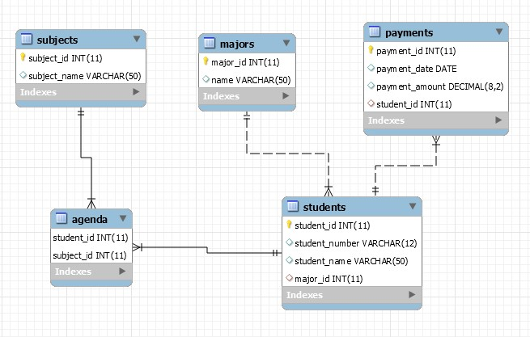

**Submit your queries by using "MySQL run queries & check DB" strategy.**

**CREATE TABLE `subjects` (**

**`subject_id` INT(11) PRIMARY KEY,**

**`subject_name` VARCHAR(50));**

**CREATE TABLE `majors` (**

**`major_id` INT(11) PRIMARY KEY,**

**`name` VARCHAR(50));**

**CREATE TABLE `payments` (**

**`payment_id` INT(11) PRIMARY KEY,**

**`payment_date` date,**

**`payment_amount` decimal(8,2),**

**`student_id` int(11));**

**CREATE TABLE `students` (**

**`student_id` INT(11) PRIMARY KEY,**

**`student_number` VARCHAR(12),**

**`student_name` VARCHAR(50),**

**`major_id` int(11));**

**CREATE TABLE `agenda` (**

**`student_id` INT(11),**

**`subject_id` int(11),**

**constraint primary key(student_id,subject_id)) ;**

**ALTER TABLE `students`**

**add constraint fk_major_id foreign key (major_id) references `majors`(`major_id`);**

**ALTER TABLE `payments`**

**add constraint fk_student_id foreign key (student_id) references `students`(`student_id`);**

**ALTER TABLE `agenda`**

**add constraint fk_student_subject_id foreign key (student_id) references `students`(`student_id`),**

**add constraint fk_subject_student_id foreign key (subject_id) references `subjects`(`subject_id`);**

## Peaks in Rila

Display all peaks for "**Rila**" mountain_range. Include:

* mountain_range
* peak_name
* peak_elevation

Peaks should be sorted by peak_elevation descending.

**SELECT**

**m.mountain_range, p.peak_name, p.elevation AS peak_elevation**

**FROM**

**mountains AS m**

**JOIN**

**peaks AS p ON p.mountain_id = m.id**

**WHERE**

**mountain_range = 'Rila'**

**ORDER BY peak_elevation DESC;**

### Example

|  |  |  |
| --- | --- | --- |
| **mountain_range** | **peak_name** | **peak_elevation** |
| Rila | Musala | 2925 |
| … | … | … |

Submit your queries by using "**MySQL prepare DB & run queries**" strategy.